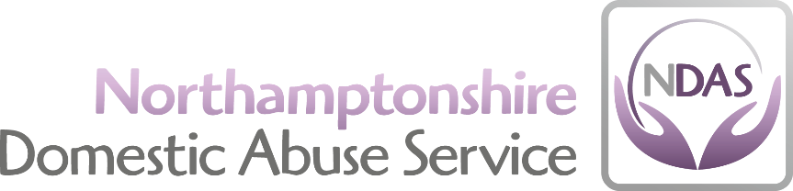

SAFER RECRUITMENT POLICY

The aim of this policy is to outline Northamptonshire Domestic Abuse’s (NDAS) recruitment procedures for all staff, both paid and voluntary, in line with recommended best practice to safeguard all clients who use NDAS services. The policy is included as part of the NDAS application pack for any position, and as such, is given to applicants along with a detailed job description, person specification, application form (CV’s are not appropriate), equal opportunities policy and equal opportunities monitoring form.
This forms an essential part of the charity’s efforts to safeguard children and young people. Recruitment and the checks that are undertaken as part of this process are the organisation’s first chance to make robust efforts to prevent unsuitable individuals from working with children, young people and vulnerable adults.
The recruitment processes consist of several stages;
- Defining the role
- Advertising
- Application
- Selection criteria
- References
- Interviews
- Reviews
This policy will go through each stage outlining key processes to ensure safer recruitment at NDAS. All colleagues involved in recruitment will receive training and development on an annual basis.
Defining the role
- A written job description and person specification is in place for each post.
- Both documents include statements about skills/behaviours/experience necessary for the post.
- The job description outlines clear boundaries of role.
- The job description describes what responsibility and opportunity for contact with children and young people there is in the role
- The job description includes statements about safeguarding responsibilities of the post
Advertising
- The adverts state NDAS’s commitment to safeguarding and the need for DBS checks for all appropriate roles.
- All candidates will be sent information about the organisation’s safe recruitment policy and practices.

Application
- All applicants must complete NDAS’s application form. CV’s are inappropriate.
- A personal statement which outlines how the applicant meets the person specification should be included.
- Applicants must sign the declaration at end of application form.
- If the application form is returned by email, the applicant must sign the application at interview if they are shortlisted for interviewing.
- The recruitment panel will explore reasons for any gaps in employment if unclear on the application form.
- Any relevant qualifications shown on the application form must be supported by certificates.
- Any offers of employment will be conditional until satisfactory references are received as well as confirmation of DBS clearance
Selection Criteria
- Applicants are asked on their application form if there is anything that they would like to declare which may come up on their criminal record bureau check that the charity should be aware of (Self disclosures).
- The short listing criteria will be based on the person specification and job description
- Minimum of two people always shortlist in order to identify gaps, inconsistencies or disclosures.
References
- NDAS requests that two referees are identified on the application form, at least one from a current employer
- All references ask about anything of concern/disciplinary action during course of employment
- Checks on the reference request form confirm details on application form such as periods of employment, reason for leaving etc.
Interviews
- All interviews are conducted with at least 2 individuals who have had safer recruitment training.
- Depending upon the position, there may be a range of selection tools appropriate to each role, such as interaction with others i.e. role play or group discussion or a written exercise used as well as an interview
- The interviews should be structured according to a common approach, which is used for each candidate and scored using a standard system.
- The questions in the interview are structured with previously agreed criteria designed to ascertain the candidate’s ability to meet the requirements of the post as per the person specification and job description.
- During the interview there are questions which probe attitudes towards children and child protection and, where appropriate motives for working with children and vulnerable adults
- Frequent changes in employment will also be probed

DBS Checks
Northamptonshire Domestic Abuse Service (NDAS) use the Disclosure and Barring Service (DBS) to help assess the suitability of applicants for positions of trust. To this end NDAS complies fully with the DBS Code of Practice and the Data Protection Act 1998 and GDPR regarding the correct handling, use, storage, retention and disposal of Disclosures and information. For further detailed information regarding DBS checks please refer to the “NDAS Disclosure and Barring Service Policy”
Further Checks
The same checks will apply to applicants from overseas and those who have lived outside the United Kingdom in the same way as for those residents in the UK. NDAS has a duty to confirm the right of those they employ to work in the UK and will make the necessary checks to ascertain this.
Review – post appointment induction and probation
NDAS conducts Probation Reviews for all paid staff and volunteers at the end of their first six months with the organisation and thereafter they have regular supervision and annual appraisals. The induction provided by NDAS covers relevant information about safeguarding and how to identify and raise concerns about the welfare of children.
Certificated training in safeguarding forms part of the compulsory training paid staff complete within six months of appointment.
New Staff Contracts
All contracts below the grade of Business Manager are signed by the Business Manager; and that in the absence of the Business Manager, contracts are signed by the CEO.
Contracts at the same post level of or above the Business Manager are signed by CEO.
CEO contract is signed by the Chair.

Reviewed: | July 2020
Next Review: | July 2022
Signed: Rachel Duncan | 