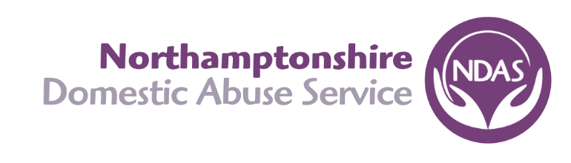
Job Description
Job Title: Children’s Domestic Abuse Specialist (CDAS)
Accountable to: CDAS Team Leader
_______________________________________________________________________________________
Purpose of Post:
- To provide a dedicated service to children and young people in Northamptonshire who have witnessed or experienced domestic abuse.
- To give children and young people the opportunity to talk about their experiences in a safe environment, to be listened to and taken seriously.
- To educate and empower children and young people to recognise the difference between a healthy and unhealthy relationship.
- To contribute to the development and review of 1:1 and group work programmes for children and young people, addressing their individual anxieties and fears following their experience of domestic abuse.
- To support and educate parents both in refuge and the community to understand the impact that domestic abuse has on their child/ren, the parent/child relationship and parenting.
- To work in conjunction with appropriate agencies surrounding children, young people and families working in a multi-agency approach to ensure all identified support needs are recorded, regularly reviewed and communicated as appropriate.
- To work alongside Domestic Abuse Specialists to ensure a cohesive, needs led service to children and parents accessing the service within the county.
- Advocate for the rights of children to be respected, heard and protected.
______________________________________________________________________________________
Main areas of responsibility:
Service Users:

- Develop positive working relationships with external agencies across the county to respond and identify needs of children and young people impacted by domestic abuse.
- Ensure adherence to NDAS safeguarding policy including the reporting and recording of all referrals. To attend or provide written reports as requested by children’s services.
- To complete initial assessments with parents, children and young people accessing the service to ensure all support needs are identified, recorded and regularly reviewed.
- To organise, plan and facilitate regular 1-1 and groupwork sessions ensuring accurate records are maintained.
- To provide regular activities for children and young people within refuge facilitating opportunities to build relationships and identify support needs. To source and refer to community activities where available.
- To support parents within refuge and the community to understand how domestic abuse impacts their children, their parenting and the parent-child relationship. This can be facilitated by 1-1 sessions, groupwork and parent drop-ins within refuge.

- To ensure all children in refuge have access to education by applying for school/nursery places. To liaise with any additional needs providers/health care professionals as required to support this process.
- Undertake a Safety Plan Assessment for each child in refuge and ensure that all identified interventions are carried out as soon as possible and regularly reviewed. Liaising with external agencies as appropriate
- To record all relevant information on case management software (electronic forms where necessary), to evidence the necessary outcomes where required ensuring this is done within agreed timescales.
- Ensure the voice of the victim is heard and documented throughout sessions.

General
- Attend regular staff meeting sharing updates and disseminating information as required.
- Promote a positive image of NDAS representing the organisation to increase professional and public awareness of the organisations work.
- Being aware of the potential for racial and/or other forms of harassment or discrimination within the refuges and the organisation and working positively to challenge any such harassment with a positive outcome for all parties.
- Comply with NDAS diversity & equality policy in all areas of work and positively promote these principles amongst colleagues, clients, and other members of the community.
- Support in the induction of new staff or students to ensure a good working knowledge of the services available.
- Liaise with external agencies to promote the work of NDAS
- Ensure equal opportunities for all service users are adhered to within the refuge, challenge any unacceptable behaviour that may cause offence or distress to other service users.
- Be available for formal work reviews/supervision as agreed with Senior Management Team.
- Undertake any other duties, which may reasonably be required by the Senior Management Team.
- Provide ‘On Call’ service to the Out of Hours team in accordance with the rota. (telephone support only)
- Undertake any other duties which may reasonably be required by the management team in line with your responsibilities as Domestic Abuse Specialist.

This list of duties and responsibilities is not exhaustive and will be reviewed regularly.

